Unmanned
Control & Tracking System
(UCATS)

Final Report

DJ³K Team

Kurt Chewning
Jennifer Greene
Dave Manley
Jeanette Smith
John Smith

Sponsors: Dr. Kuo-Chu Chang
&
Ashwin Samant
Department of Systems Engineering & Operations Research
SYST 798 Applied Projects Course
Fall 2009

EXECUTIVE SUMMARY
The coordination of airborne Unmanned Arial Vehicles (UAVs), which are used to track targets, is a labor-intensive task. A team of five George Mason University (GMU) students, Team DJ³K, was tasked to define and design a system which would reduce the manpower requirements for commanding, controlling, and directing in flight UAVs to Targets of Interest (TOIs); so, the UAV can begin autonomous tracking operations. The team members of team DJ³K are: Kurt Chewning, Jennifer Greene, Dave Manley, Jeanette Smith, and John Smith.

The Unmanned Control and Tracking System (UCATS) is a command and control system. The primary mission of UCATS is to recommend which in-flight UAVs should track particular Targets of Interest (TOI), calculate and recommend UAV to TOI intercept route, monitor UAV position, estimate TOI route, and redirect the UAVs if new tasking arrives.

There is a need to minimize the number of operators and/or time required to control and coordinate UAVs. Dr. K.C. Chang, GMU professor of Systems Engineering and Operations Research, and Ashwin Samant, a GMU PhD student have developed an algorithm to allow UAVs to autonomously track TOIs in urban environments; however, the algorithm does not address the routing of UAVs to TOIs and the assignment of UAVs to TOIs. Therefore, a system is needed that can route several in-flight UAVs to the TOIs based on the priority of the TOI. UCATS will provide the routing and communication functions. Dr. Chang and Ashwin Samant are developing the tracking software, the initial Graphical User Interface (GUI), and the algorithm needed to allow UAVs to autonomously track TOIs. Team DJ³K was tasked to design the UCATS system and add the capability to assign UAVs to TOI in the algorithm.

Team DJ³K used a systems engineering process to design UCATS, and generated the systems engineering documents and artifact needed to adequately describe the UCATS systems design. The team developed a Statement of Work (SOW) to define customer deliverables. The team developed a Project Management Plan (PMP) to identify roles and responsibilities of the team. The PMP also contains the UCATS project schedule. The team developed a Risk Management Plan (RMP) with identified UCATS risks. This plan was used to manage and mitigate the UCATS risks. The Systems Engineering Management Plan (SEMP) was developed to describe the systems engineering process used during UCATS development. A Product Assurance Plan (PAP) was developed to ensure quality products. The team used sound configuration management (CM) and the team website contains CM controlled artifacts. The team used several engineering tools some of these tools are: CORE, Visio, Google Maps, Matlab, Java, Excel, DPL, and Javascript.

A business case was developed for UCATS. This business case shows the UCATS market strategy, the cost model and sensitivity analysis. The business case shows the results of the following factors: price, cash flow analysis, net present value (NPV), internal rate of return, and breakeven point. For the financial model sensitivity analysis, NPV was calculated for three different cases to determine how the model reacted to changes in costs, selling price, and cost-of-capital (interest rate), and the NPV for the baseline was $20,894,683. The business case also takes into consideration the inputs from the Stakeholder Value Mapping (SVM) Document. Team DJ³K’s business concept for UCATS involves developing it using sponsor funding and sell it to Department of Defense (DoD) customers. Once UCATS is developed, military, homeland defense, and law enforcement agencies may be interested in procuring UCATS. The business case also analyzed two key marketing strategy decisions: in-house development vs. contractor development and aggressive advertising vs. low advertising. The end result, using profit as the model’s objective function, of this decision analysis recommends in-house development and aggressive advertising with an expected value of $54,605,642.75.

Team DJ³K developed deliverable and design products using the spiral development philosophy. The team first defined the scope of the problem. This involved defining the problem and setting a design goal. The team developed a concept of operations (CONOPS), use cases for the system, SVM, activity diagrams, and external systems diagrams. The SVM contains sixteen key stakeholder needs; each of the needs is assigned a relative weight. The weights in the SVM are used when identifying design criteria. The CONOPS, activity diagrams, and external system diagram are all used to define the scope of the UCATS and feed into the UCATS System Requirements Specification (SRS). The UCATS SRS is approved by the UCATS sponsor, Dr. Chang.

The team used the requirements in the SRS to define a Functional Architecture. The team used CORE to model the functional architecture. A generic physical architecture was also defined. The team mapped UCATS requirements to functions and components to ensure the architecture satisfies the UCATS requirements. The UCATS team used several Analyses of Alternatives (AoAs), to develop the UCATS instantiated physical architecture. Team DJ³K defined instantiated architecture for the UCATS communication module, video module, and the UCATS ground command and control station. The team also defined the UCATS software architecture and developed a human computer interface (HCI) specification.

Based on the systems engineering process and the documents and artifacts described above, Team DJ³K determined the UCATS system design was a ground control trailer that had both Satellite Communication and Line of Sight radios, an encryption module to encrypt outgoing and decrypt incoming transmissions, and an operator station that contains a PC based computer with processor(s) that runs UCATS software and algorithm, two displays for UCATS-to-operator interface, and one display for surveillance video. In addition to the ground control trailer, the UCATS design included a UAV, which acts as a communication relay to the surveillance UAVs. A key requirement of the primary stakeholder was the UCATS algorithm. The algorithm was enhanced to assign UAVs to TOIs using both local optimization and global optimization. The team found that the local optimization and global optimization find identical solutions eighty percent of the time. The local optimization has better performance in terms of time and is the recommendation of the UCATS team.

The UCATS has a sound system design and the DJ³K recommends that UCATS is ready to proceed into the detailed design phase of development.

TABLE OF CONTENTS
EXECUTIVE SUMMARY ii
1. INTRODUCTION 1
2. BACKGROUND 1
2.1 PROBLEM STATEMENT 2
2.2 MISSION STATEMENT 2
3. SCOPE DEFINITION 2
3.1 STAKEHOLDER ANALYSIS 2
3.1.1 STAKEHOLDER IDENTIFICATION 3
3.1.2 Stakeholder Needs Assessment 4
3.1.3 Stakeholder Needs Weighting 4
3.2 CONCEPT OF OPERATIONS 5
3.3 SCOPE OF WORK 6
3.4 SYSTEM-OF-SYSTEM (SOS) DEFINITION 8
4. SYSTEM ENGINEERING MANAGEMENT 9
4.1 PRODUCT ASSURANCE PLAN 10
4.2 RISK ANALYSIS 10
5. REQUIREMENTS 10
6. FUNCTIONAL AND GENERIC PHYSICAL ARCHITECTURE 10
6.1 SYSTEM-OF-SYSTEMS FUNCTIONAL MODEL ANALYSIS 11
6.2 UCATS LEVEL 1 ARCHITECTURE 12
6.2.1 Level 1 Functional Architecture 12
6.2.2 Level 1 Generic Physical Architecture 13
6.3 UCATS LEVEL 2 ARCHITECTURE 14
6.3.1 UAV Communications 14
6.3.2 Operator Interface with UCATS 14
6.3.3 UCATS Computations 14
6.3.4 Providing Surveillance to the Operator 15
6.3.5 Requirements Mapping 15
7. PHYSICAL INSTANTIATED ARCHITECTURE 16
7.1 COMMUNICATIONS MODULE 18
7.1.1 COMMUNICATION ENCRYPT / DECRYPT MODULE 18
7.2 COMMUNICATIONS PROCESSOR 18
7.2.1 COMMUNICATIONS RECEIVER / TRANSMITTER MODULE 18
7.3 INTERFACE MODULE 18
7.4 PRESETTING ALGORITHM MODULE 19
7.5 VIDEO MODULE 19
7.6 C2 DESIGN 19
7.7 SUMMARY 19
8. ALGORITHM DEVELOPMENT 20
8.1 Priority Algorithm 20
8.2 UCATS Simulation 21
9. BUSINESS CASE 21
10. FUTURE WORK 23
11. CONCLUSIONS AND RECOMMENDATIONS 24
TABLE OF FIGURES

Figure 1: Baseline GUI Design 2
Figure 2: UCATS Stakeholders 3
Figure 3: UCATS CONOPs 6
Figure 4: UCATS Organizational Chart 7
Figure 5: UCATS Schedule 7
Figure 6: System-of-Systems Diagram 8
Figure 7: External System-of-Systems IDEF0 Diagram 9
Figure 7: Functional and Generic Physical Architecture Development Process 11
Figure 9: UCATS System Level Function Definition Process 12
Figure 10: UCATS Functional Architecture Definition Process 13
Figure 11: UCATS Functional Model 13
Figure 12: Communications Module Generic Physical Architecture 15
Figure 13: Interface Module Generic Physical Architecture 15
Figure 14: Presetting Algorithm Generic Physical Architecture 15
Figure 15: Video Module Generic Physical Architecture 15
Figure 16: Integrated UCATS Instantiated Architecture 20
Figure 17: DoD UAV Spending 22
Figure 18: Baseline Cash flow Chart 23

TABLE OF FIGURES

Table 1: Stakeholder Needs 4
Table 2: Value Scale and Stakeholder Weights 5
Table 3: Value Mapping 5
Table 4: Risk Analysis Summary 10
Table 5: Instantiated Physical Architecture Summary 16
Table 6: SVM Criteria Trade-Study Summary 17

LIST OF APPENDICIES

Appendix A: ACRONYMS II
Appendix B: ASSUMPTIONS III
Appendix C: STATEMENT OF WORK IV
Appendix D: STAKEHOLDER VALUE MAPPING IV
Appendix E: CONCEPT OF OPERATIONS IV
Appendix F: PROJECT MANAGEMENT PLAN IV
Appendix G: SYSTEM OF SYSTEMS CORE FILES IV
Appendix H: SYSTEMS ENGINEERING MANAGEMENT PLAN IV
Appendix I: PRODUCT ASSURANCE PLAN IV
Appendix J: RISK MANAGEMENT PLAN IV
Appendix K: SYSTEM REQUIREMENT SPECIFICATION IV
Appendix L: USE CASES IV
Appendix M: ACTIVITY DIAGRAMS IV
Appendix N: P-DIAGRAM V
Appendix O: FUNCTIONAL MODEL ANALYSIS V
Appendix P: ARCHITECTURE V
Appendix Q: COMMUNICATION ANALYSIS OF ALTERNATIVES V
Appendix R: HUMAN COMPUTER INTERFACE SPECIFICATION V
Appendix S: ALGORITHM ANALYSIS OF ALTERNATIVES V
Appendix T: GROUND CONTROL ANALYSIS OF ALTERNATIVES V
Appendix U: BUSINESS CASE V
Appendix V: REFERENCES V

- INTRODUCTION
This Final Report culminates a semester-long effort of Team DJ³K for the Unmanned Control and Tracking System (UCATS) Project. Team DJ³K used a discipline systems engineering process to develop the UCATS system level design in addition to generating a proposed business case for the UCATS design. This report summarizes the tasks and activities Team DJ³K used for the design and development of a UCATS system design and prototype, the UCATS business case, and recommendations for future work on UCATS. UCATS provides command and control functions for Unmanned Aerial Vehicles (UAVs) that have autonomous surveillance capability. UCATS directs the UAVs to the area requiring surveillance, and the UAVs then autonomous conduct surveillance on Targets of Interest (TOIs). Dr. K.C. Chang from the George Mason University (GMU) sponsored the UCATS project and autonomous surveillance UAV project. Ashwin Samant, also from GMU, provided technical assistance in developing the UCATS prototype and is developing the prototype for the autonomous surveillance UAVs. Both Dr. Chang and Mr. Samant needed a decision support algorithm that will enable an operator to control a group of UAVs from a remote location.
- BACKGROUND

The intent of the UCATS project is to provide Command and Control (C2) functions to surveillance UAVs in urban environments. One of the many challenges in the deployment of UAVs is the need to minimize the amount of operators required to control and coordinate them. One solution for this problem is incorporating autonomous control of UAVs. Dr, K.C. Chang and Ashwin Samant have been working on the algorithms needed to allow UAVs to autonomously track TOIs in urban environments; however, it is also necessary to develop a system that can route several in-flight UAVs to the TOIs based on the priority of the TOI and receive the surveillance data from the UAVs as they autonomously track the TOI. UCATS will provide the routing and communication functions.

Dr. K.C. Chang, GMU professor of Systems Engineering and Operations Research, and Ashwin Samant, a GMU PhD student are developing the tracking software, the initial Graphical User Interface (GUI) and the algorithm needed to allow UAVs to autonomously track TOIs. The software, GUI, and algorithm use the Google Maps and Google Earth API, Matlab, and Eclipse IDE for JavaScript and HTML. The tracking algorithm estimates the waypoints followed by the UAV based on the motion and heading of the target. The tracking algorithm uses Tangent-Plus-Lyapunov vector field guidance. At the start of the UCATS project, the UAV tracking software was developed for a single UAV. The intent is to expand this up to five UAVs. Also, the initial algorithm does take into account obstacle avoidance with a simple model, but it was not integrated into the GUI. The GUI utilizes the 2D and 3D capability of Google Earth and Google Maps and the ability to view different angles and altitudes, enabling the operator to track and monitor targets in an urban environment. Figure 1 illustrates the baseline GUI design at the start of the UCATS project.

The UCATS project will complement the project to develop autonomous tracking of UAVs in urban environments by routing those surveillance UAVs to the TOI location and communicating with the UAVs as they autonomously track the TOIs. Without a system like UCATS, determining the UAV routes manually would take too much time, especially considering that the TOIs are mobile, which means the more time it takes to get the UAVs to the TOI, the greater the probability the UAV cannot find the TOI for tracking operations. Additionally, the actual routing of the UAVs is labor intensive; so, the ability to coordinate this routing would greatly decrease manpower.
summarizes the assumptions Dr. Chang provided to Team DJ³K. For more background and project information see the Statement of Work (SOW) in Appendix C.

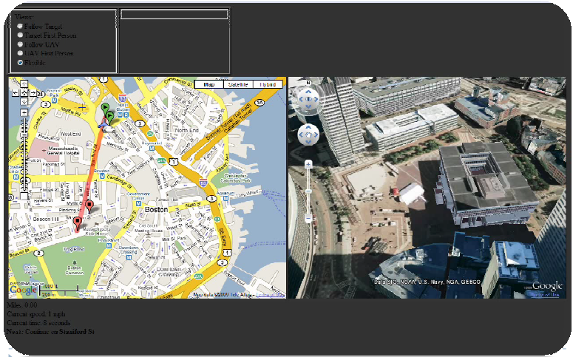
Figure 1: Baseline GUI Design

PROBLEM STATEMENT
Tracking Targets of Interest in densely populated areas present unique and difficult problems when ensuring public safety and security. Coordinating airborne UAVs to incept and track a TOI in an urban environment is time consuming and labor intensive.

MISSION STATEMENT
UCATS is a command and control system designed to route UAVs to TOI, monitor the UAV location, and redirect the UAVs when new tasking arrives. The primary mission of the UCATS is to recommend which airborne UAVs should track TOIs and then direct the UAVs on a TOI intercept course, monitor UAV position, and redirect the UAVs as new TOI tasking becomes available. The goal of UCATS is to reduce manpower from five operators to a single operator and reduce mission planning time from 45 minutes to 15 minutes or less. The 45 minutes is based on the time it took to manually calculate the intercept route of one TOI, which was 9 -10 minutes. The maximum number of TOIs is five; therefore, the baseline manually calculated time is 45 minutes.
- SCOPE DEFINITION

STAKEHOLDER ANALYSIS
Team DJ³K met with Dr. KC Chang, our project sponsor, and Ashwin Samant to discover more about the project at hand. Meetings were held throughout the semester both in-person and through email and telephone. The purpose of these interviews was to further understand the stakeholder interests and tailor the UCATS project around their needs. These interviews also allowed the stakeholders to express their requirements and needs for the UCATS and helped get everyone “on the same page.”

Along with the interviews of Dr. Chang and Ashwin, Team DJ³K also had the benefit of all being current government or former DoD (Department of Defense) employees. While not all of Team DJ³K works on UAV systems we all have an understanding of the government and military thought process. One member of the team works in the UAV branch at the Naval Surface Warfare Center in Dahlgren, VA and his inputs were very valuable to the project.

While the team did not have the ability to interview all of the stakeholders listed in the preceding sections, we analyzed them using our own knowledge and experiences. This, along with interviews of some of our stakeholders, allowed us to gain insight into the UCATS project from multiple perspectives. The general process used to determine the stakeholder values was: (1) determine the applicable UCATS stakeholders; (2) determine the stakeholder needs; and (3) determining the relative weight for those needs.
    - STAKEHOLDER IDENTIFICATION
Team DJ³K assessed the applicable UCATS stakeholders, and divided them into the following categories: Government, Military, and Civilian. Figure 2 shows the three categories of stakeholders and the groups that belong to each category. This assessment was based on analyzing the impact UCATS will have on these stakeholders and determining what service that UCATS will provide to the stakeholder.
- Government: Department of Homeland Security (DHS), Drug Enforcement Administration (DEA), U.S. Customs & Border Protection (CBP), Federal Bureau of Investigation (FBI), and Central Intelligence Agency (CIA)
- Military: Armed Forces
- Civilian: Systems Engineering & Operations Research (SEOR) Faculty and Sponsor, Industry, the Urban Community, and team DJ³K
Within these three categories there are some individuals, groups, and systems that UCATS interacts with during its operation and implementation. Depending on the stakeholders above these could be military, government, or civilian roles or systems. These include the UCATS operator, Tasking Authority, the UCATS maintainer, UAVs, and the communication system.
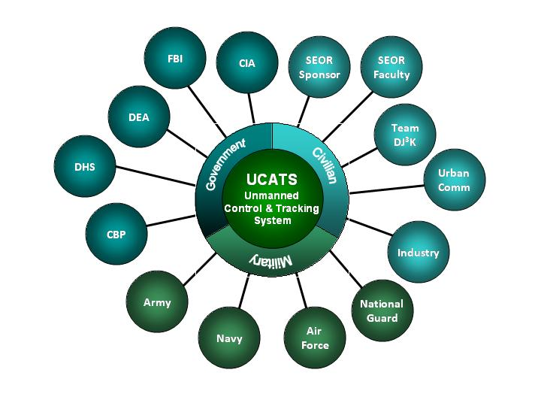
Figure 2: UCATS Stakeholders

    - Stakeholder Needs Assessment
After identifying the stakeholders, Team DJ³K worked with the available stakeholders, primarily the SEOR sponsor and activity, to determine their needs for UCATS, and estimated the needs of the other stakeholder. If it had been practical, Team DJ³K would have contacted all the stakeholders to determine their needs. As the project progressed, Team DJ³K updated the stakeholder needs as new insight or stakeholder input was obtained. Team DJ³K used this process to determine the stakeholder needs shown in Table 1.

Need | Definition
Accuracy: | The accuracy of information the UCATS provides.
Affordability | A cost-effective solution to command and control UAVs.
Safety | Safety of personnel and the urban community.
Security | Communication and operational security.
Reliability | Reliability is the probability the UCATS will function as designed without failures and/or outages.
Maintainability | To keep the UCATS in good repair.
Transparency of Operations | The ability to “see” how the UCATS components are functioning.
Usability | How easy the UCATS is to use.
Availability | How often UCATS is available for use.
Interoperability | How easy it is for UCATS and UAVs to exchange information and use the information that has been exchanged.
Portability | How readily transportable the UCATS C2 station from one location to another.
Reproducibility | The ability for UCATS to generate the same outputs given identical inputs.
Performance | UCATS will perform according to the design.
Flexibility | The ability of the UCATS design to adapt when external changes occur. The ease with which the UCATS can respond to uncertainty in a manner to sustain or increase its value delivery.
Extensibility | The ability of the UCATS design and implementation to take into consideration future growth. A systemic measure of the ability to extend the UCATS and the level of effort required to implement the extension.
Agility | The ability of UCATS to rapidly and cost efficiently adapting to changes.
Table 1: Stakeholder Needs
    - Stakeholder Needs Weighting
After identifying the needs, team DJ³K determined the importance (or weighting) of the need by having the stakeholders provide a value to the need and calculating a relative weight for the need by considering the importance of the stakeholder (or stakeholder weight). Table 2 summarizes the value scale used to rank each need, and the stakeholder weighting scale. Weights were also assigned to each stakeholder, from most important stakeholder to least important. Dr. Chang is the primary stakeholder that team DJ³K is focusing on and industry and the urban community are the least important.

Value Scale
4 | The feature is critical for stakeholder satisfaction.
3 | The feature is highly recommended for stakeholder satisfaction.
2 | The feature is nice to have but not necessary.
1 | The feature provides minimal value but not necessary.
0 | The feature provides no added value to stakeholder satisfaction.
Stakeholder Weights
4 | SEOR Sponsor
3 | Team DJ³K
3 | SEOR Faculty
2 | Armed Forces
2 | CBP, DHS, DEA, FBI, CIA
1 | Industry
1 | Urban Community
Table 2: Value Scale and Stakeholder Weights

After determining the stakeholder weights, needs, and value scale, Team DJ³K developed the following UCATS Stakeholder Needs Analysis Matrix in Table 3. Relative weights were calculated for each need. The most important needs were identified to be performance and accuracy immediately followed by interoperability, availability, usability and security. The least important needs were transparency of operations and maintainability. Team DJ³K will ensure that these needs are heavily taken into consideration when designing the UCATS. The Stakeholder Value Mapping Report is shown in Appendix D.

Needs Analysis Matrix
Need # | Need | Stakeholders
 |  | SEOR Sponsor | SEOR Faculty | Team DJ³K | Armed Forces | CBP, DHS, DEA, FBI, CIA | Industry | Urban Community | Relative Weight
1 | Accuracy | 3 | 3 | 4 | 4 | 4 | 2 | 2 | 53
2 | Affordability | 1 | 3 | 0 | 3 | 4 | 3 | 2 | 32
3 | Safety | 2 | 2 | 3 | 4 | 4 | 2 | 4 | 45
4 | Security | 3 | 3 | 3 | 4 | 4 | 2 | 2 | 50
5 | Reliability | 3 | 3 | 3 | 3 | 3 | 3 | 2 | 47
6 | Maintainability | 2 | 2 | 1 | 3 | 3 | 2 | 0 | 31
7 | Transparency of Operations | 1 | 1 | 1 | 2 | 2 | 1 | 0 | 19
8 | Usability | 4 | 4 | 3 | 3 | 3 | 2 | 0 | 51
9 | Availability | 3 | 3 | 2 | 4 | 4 | 1 | 0 | 52
10 | Interoperability | 3 | 3 | 4 | 4 | 4 | 3 | 0 | 52
11 | Portability | 3 | 3 | 1 | 2 | 2 | 1 | 0 | 33
12 | Reproducibility | 2 | 2 | 4 | 3 | 3 | 3 | 0 | 41
13 | Performance | 4 | 4 | 3 | 3 | 3 | 3 | 1 | 53
14 | Flexibility | 4 | 3 | 2 | 3 | 3 | 3 | 1 | 47
15 | Extensibility | 3 | 3 | 3 | 3 | 3 | 3 | 2 | 47
16 | Agility | 3 | 3 | 2 | 3 | 3 | 3 | 2 | 44
Table 3: Value Mapping

CONCEPT OF OPERATIONS
The UCATS is a C2 system that directs in-flight UAVs to TOIs. The UAVs can autonomously track the mobile TOIs in an urban environment. The primary mission of the UCATS is to recommend which airborne UAVs should track TOIs and then direct the UAVs on a TOI intercept course, monitor UAV position, and redirect the UAVs as new TOI tasking becomes available. The UCATS will reduce the manpower requirements encountered in the management of UAVs and the time required to generate an optimum plan to have airborne UAVs intercept a TOI.

The UCATS reduces the manpower resources by determining which in-flight UAVs are best capable to track TOIs, recommending a UAV intercept course, monitoring the position of the UAVs, and providing re-tasking if the operator needs to track a new TOI. The time needed to generate intercept tasking is important when considering the TOIs are mobile. The shorter the time required to generate intercept tasking, the better the prediction of where the TOIs may have gone. This increases the likelihood the UAVs will find the TOI to track. This collaborative control will increase efficiency, save money and resources, and aide in security and homeland defense.

External systems that directly interface with UCATS are the UCATS operator and up to five airborne UAVs. UCATS will provide a decision support component to enable effective communication from the operator to the UAVs conducting the mission. During operations, the UCATS operator will receive a request to track mobile TOIs in an urban environment, which will include a prioritized list of the TOIs. The operator inputs this request to UCATS, and UCATS recommends an intercept plan to the operator and communicates with UAVs. The intercept plan includes predicting the TOI location at UAV intercept, determining if the intercept is feasible, recommending a UAV intercept course, and recommends a UAV-to-TOI assignment. The UCATS will then use those tasking requirements to generate an intercept plan. The UAVs then fly the intercept courses directed by UCATS, and once identified by the operator; the UAVs then begin to autonomously track the TOIs. UCATS is capable of generating intercept plans and communicating with up to five airborne UAVs. During surveillance, the UCATS provides surveillance video from the UAVs to the operator. As the operators, receives new TOIs and tasking, they will then use the UCATS to re-evaluate the UAV tasking and then redirect the UAVs as needed. Figure 3 provides a notional view of the UCATS Concept of Operation (CONOPS).

The use of UCATS in conjunction with UAVs that can autonomously track TOIs has several potential uses. A system such as this could be used by the Department of Defense in the execution of the Global War On Terror (GWOT). Other agencies within the United States Government could have uses for this system such as: Border Patrol, DEA, FBI, DHS, and the CIA. The UCATS CONOPS is shown in Appendix E.

Figure 3: UCATS CONOPs

SCOPE OF WORK
The System design phase was conducted by a 5 person-semester effort. The timeframe of the work was from August 31 to December 18, 2009. The work is to be done by the DJ³K, composed of five team members of the GMU Systems Engineering Masters program, and with the assistance of GMU Systems Engineering and Operation Research PhD student Ashwin Samant as a technical consultant. Given the limited personnel involved with this project the chart in Figure 4 shows the leads of the task performed.
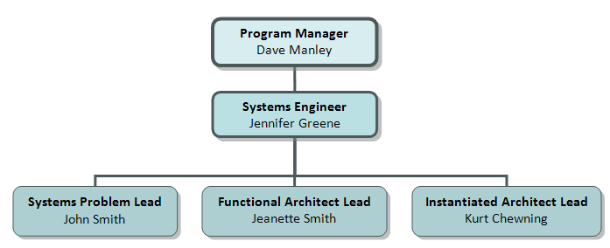
Figure 4: UCATS Organizational Chart

The work stated in the SOW was performed at the Naval Surface Warfare Center, Dahlgren, and at GMU, Fairfax Campus. The DJ³K team visited GMU during the semester as needed. Phone conferences and email where also modes of communication. Information exchange occurred through DJ³K’s website (http://mason.gmu.edu/~jgreene7/ ) and emailing and deliverables where made through GMU blackboard website (https://gmu.blackboard.com/ ).

See Appendix F for more details on the Project Management Plan and Appendix C for the SOW which contains the project schedule showing the planned effort and completion dates. Figure 5 shows the UCATS schedule.
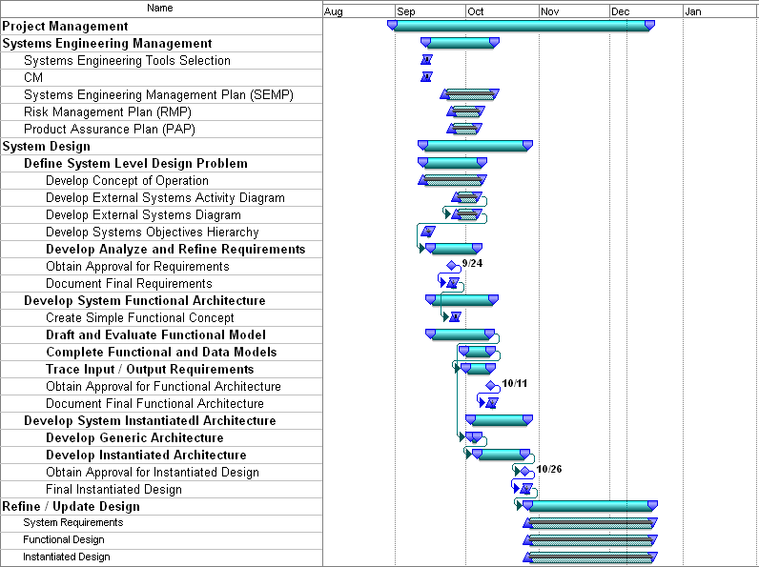 Figure 5: UCATS Schedule

The UAV tracking software was originally developed for single UAV. A separate project will expand this capability for multiple UAVs to collaboratively track multiple targets. The development of the control and communication part of the algorithm is the key interest to the primary stakeholder: K.C. Chang, which encompasses one of the primary functions for UCATS. An integral part for the autonomous control of UAVs is the assignment and prioritizing of UAVs.

SYSTEM-OF-SYSTEM (SOS) DEFINITION
Figure 6 and Figure 7 depict the system-of-system functionality for UCATS. Section 6 describes the process used to determine the UCATS functionality and describes the UCATS functionality in more detail. In summary, the system of system functionality is tasking the operator, providing command and control functions, operating UCATS, and providing tracking functionality. UCATS functionality is encompassed by the “Provides Command and Control Functions”. For details on the external system diagram see the CORE files included in the Appendix G.

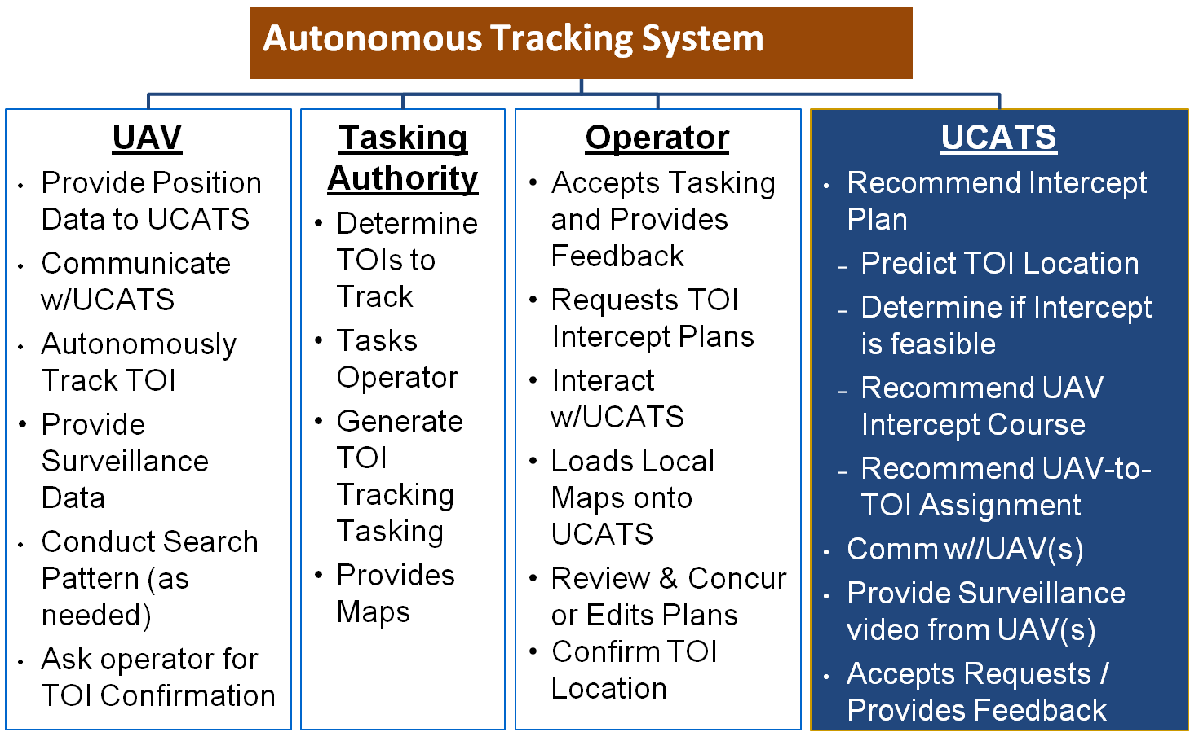
Figure 6: System-of-Systems Diagram

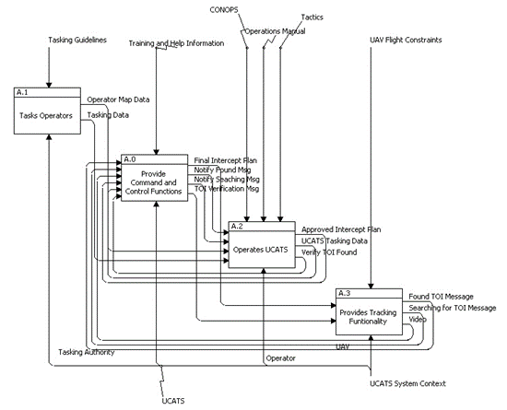
Figure 7: External System-of-Systems IDEF0 Diagram

- SYSTEM ENGINEERING MANAGEMENT
Team DJ3K developed a System Engineering Management Plan (SEMP) to identify and describe the overall organization, tasking, schedule, policies and processes for System Engineering Management (SEM) to be used during the UCATS development for George Mason University SYST 798 class. The primary intention of the SEMP is to provide information on the SEM policy and methods to be adopted and implemented for the project. See Appendix H for the SEMP document.

The UCATS systems engineering process philosophy for UCATS was to use the “Vee” Model. Using the “Vee” Model approach, Team DJ³K (1) Defined the System Level Problem; (2) Defined the System Requirements; and (3) Determined the System Level Functional and Physical Design. Team DJ³K developed the various systems engineering products and artifacts included in each step using a spiral philosophy to improve the fidelity of the product or artifact as more information was obtained but we did not use the spiral model. Eventually the fidelity was sufficient to proceed to the next step in the “Vee” process.

The Engineering Tools Team DJ³K used to develop the engineering products were CORE for architecture design; Visio for SysML modeling; and Google Maps and Google Earth API, Matlab, and Eclipse IDE for JavaScript and HTML for the algorithm development. Team DJ³K maintained configuration management of the UCATS design products and artifacts using the UCATS website, which was maintained by a single person to ensure configuration control of the completed products and artifacts.

PRODUCT ASSURANCE PLAN
Team DJ³K generated a Product Assurance Plan (PAP) that described the product assurance objectives, policies, methods, and procedures that will be implemented by team DJ³K throughout UCATS development and design phases to the delivery of systems to customers. The scope of this PAP is beyond the scope of the UCATS projects, which ends at the System Level design and at delivery of systems to the customer. The benefit of the PAP for the UCATS project was to identify the processes, procedures and standards Team DJ³K will use to provide high quality product and services during the generation of the system design. See Appendix I for more details on the PAP.

RISK ANALYSIS
Team DJ³K generated a Risk Management Plan (RMP) to describe risk management process for the UCATS system. Table 4 is the list of UCATS System risks as they were initially entered into the UCATS risk management database during the conduct of the UCATS project. Each risk has an event that could occur and its possible consequence. A risk code is derived for each risk event using the risk assessment guide in Appendix J. For each risk event a mitigation plan was described. Team DJ³K was able to mitigate all risks during the conduct of the project, and all the risks were eventually mitigated to low risks.

Priority  Risk | Risk ID  Number | Risk Title | Probability | Impact | Risk  Level |  | Change |  | Responsible  Person
1 | 001 | Communications Reliability | Frequent | Extremely High | .41 |  |  | NEW | Team DJ³K
2 | 002 | UAV Assignment Algorithm | Occasional | Extremely High | .27 |  |  | NEW | Team DJ³K
4 | 003 | Timeframe | Occasional | High | .15 |  |  | NEW | Team DJ³K
5 | 004 | Team Distance Constraints | Likely | Moderate | .06 |  |  | NEW | Team DJ³K
6 | 005 | Routing of UAVs | Unlikely | High | .005 |  |  | NEW | Team DJ³K
3 | 006 | Algorithm Requirements Creep | Occasional | Very High | .21 |  |  | NEW | Team DJ³K
1 | 007 | Lack of Sponsor Approval | Frequent | Extremely High | .41 |  |  | NEW | Team DJ³K
Table 4: Risk Analysis Summary
- REQUIREMENTS
Team DJ³K generated a System Requirements Specification (SRS) document to capture the requirements for the UCATS. DJ³K Requirements group prepared this document in accordance with the Statement of Work. Team DJ³K generated an initial draft of the SRS using the CONOPs, System-of-System Functional description, Use Cases, and SVM. Team DJ³K refined the fidelity and completeness of the document as the team generated the SOS External Systems Diagram and UCATS IDEF0 Diagram. This document was approved and baselined as the complete set of requirements for the development of UCATS. The SRS was approved with minor modifications by the sponsor on October 30, 2009. The SRS contains mission level, training, and operational requirements for the UCATS. See Appendix K for details on the SRS document.
- FUNCTIONAL AND GENERIC PHYSICAL ARCHITECTURE
Figure 8 depicts the process used to develop the system level functional and physical architecture and the next level of decomposition of the individual functions and generic physical components. The process used to develop the functional and physical architecture of the UCATS includes:
- Define the required UCATS functions based on the external systems diagram, UCATS operational concept, and UCATS Use Cases.
- Develop the Level One Functionality; develop the Generic Physical Architecture; define inputs, outputs, and constraints for all functions; and verify that all functionalities map to the generic physical architecture.
- Decompose Level One functionality into Level Two functionality; decompose the Level One Generic Physical Architecture into a Level Two architecture; define inputs, outputs, and constraints for all Level Two functions; and verify that all Level Two functionalities map to the generic physical architecture.
- Map functions to SRS requirements and verify that all UCATS requirements map to a UCATS function and component.
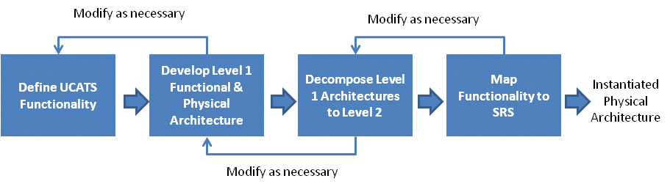
Figure 8: Functional and Generic Physical Architecture Development Process

SYSTEM-OF-SYSTEMS FUNCTIONAL MODEL ANALYSIS
Figure 9 shows the process Team DJ³K used to identify the required UCATS functionality. The specific products used were system level use cases for UCATS, shown in Appendix L; systems-of-system activity diagram, shown in Appendix M; external system-of-systems diagram, shown in Figure 7; and the UCATS P-Diagram, shown in Appendix N.

Based on this process, Team DJ³K identified a simple functional concept and developed the functional model for the UCATS. UCATS primary functions include: recommend an intercept plan to the operator, communicate with UAVs, provide surveillance video from the UAVs to the operator, and accept operator’s requests and provide feedback. Team DJ³K evaluated the proposed UCATS function model concepts by conducting a multi-attribute trade study using a utility model to evaluate the proposed concepts. See Appendix O for a description on the UCATS primary functions, the evaluation criteria and their respective weighting of the utility model.

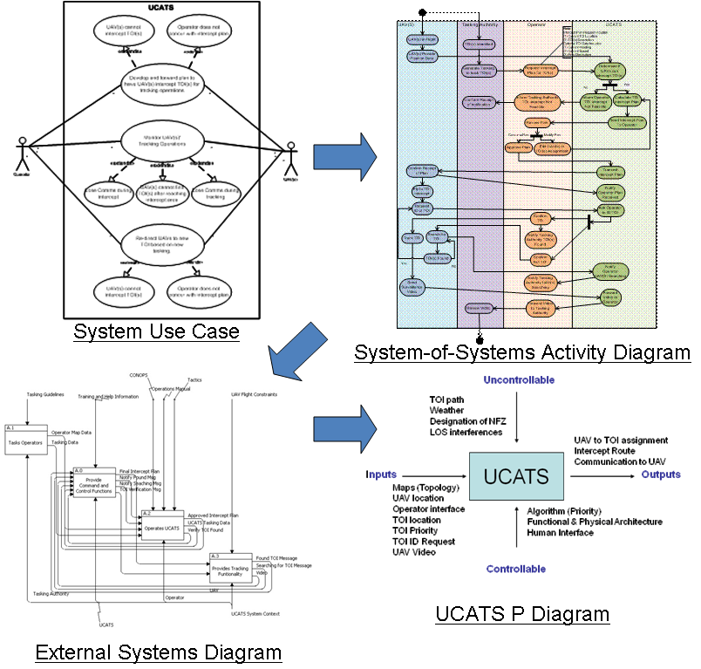
Figure 9: UCATS System Level Function Definition Process

UCATS LEVEL 1 ARCHITECTURE
A description of the UCATS Level 1 Function and Physical Architecture is described in Appendix P. Using the UCATS system functionality defined in the system level functional model, Team DJ3K then decomposed these functions into Level 1 functional and generic physical architectures.
    - Level 1 Functional Architecture
Figure 10 shows the process Team DJ³K used to identify the Level 1 Functional and Generic Physical Architecture. Figure 11 depicts the top level function for UCATS, and Appendix G shows how these functions were then decomposed to the 1st and 2nd level system architecture. Based on this functional hierarchy, Team DJ³K then modeled the system using an UCATS activity diagram, shown Appendix M which was used to identify inputs and outputs to each of the sub-functions. Team DJ³K then added the constraints and generic components, which was used to generate the IDEF0 model, shown in Appendix G.

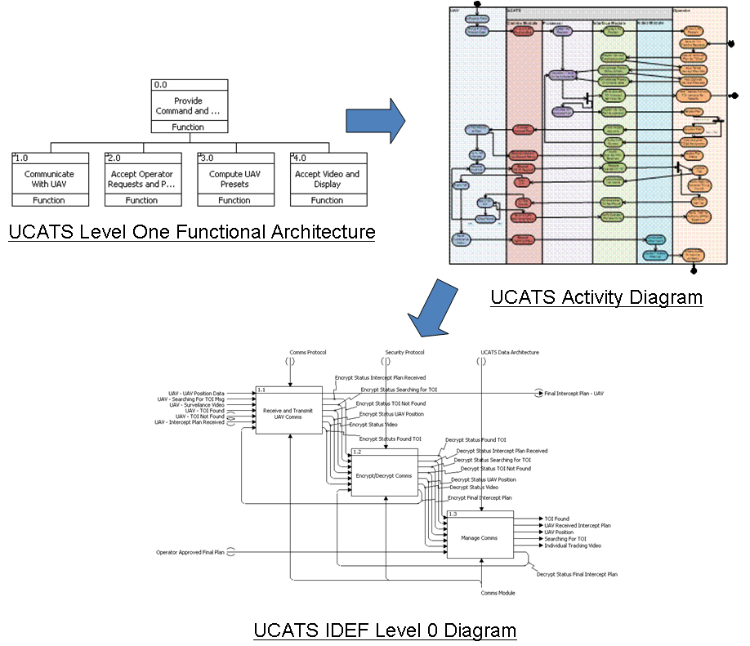
Figure 10: UCATS Functional Architecture Definition Process

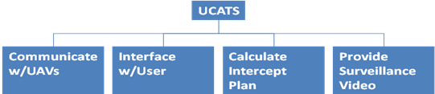
Figure 11: UCATS Functional Model
    - Level 1 Generic Physical Architecture
Using the functionalities and the generic physical architecture used during the development of the UCATS Level 1 IDEF 0 Diagram, Team DJ3K generated the generic physical architecture, shown in Figure11. Team DJ³K then mapped the generic physical architecture to the functional architecture to verify the generic physical architecture addressed all required functionality. A summary of the generic physical architecture and the functionality they perform is:
- Communications Module: The Communications Module sends and receives data from surveillance UAVs. This component is the interface between the UCATS and UAVs.
- Interface Module: The Interface Module accepts data from and displays data to the operator. The component is the interface between UCATS and the operator. The Interface Module contains the windows and displays necessary for the user to interact with the UCATS.
- UCATS Presetting Algorithm Module: The Algorithm Module executes the calculations which make recommendation to the user. The Algorithm Module calculates estimated TOI, TOI route, estimated UAV intercept routes and UAV to TOI assignments.
- Video Module: The Video Module receives single video feeds from each UAV. It then consolidates the video feeds and displays the videos to the user.

UCATS LEVEL 2 ARCHITECTURE
A description of the UCATS Level 1 Function and Physical Architecture is described in Appendix P. Team DJ³K developed the Level 2 functional and generic physical architectures by decomposing each of the Level 1 functions and components. Inputs, outputs and constraints were developed during the decomposition process.
    - UAV Communications
The decomposed Level 2 functions for UAV communications includes:
- Receive and Transmit UAV Communications: Receives encrypted messages from the UAV and sends encrypted messages from UCATS to the UAV.
- Encrypt and Decrypt UAV Communications: Manages the Encryption and Decryption of UAV messages.
- Manage Communications: Sends decrypted data to the other components of UCATS,

Based on these functions, Team DJ³K decomposed the UCATS Level 1 generic physical architecture to the UAV Communications generic physical architecture shown in Figure 12.
    - Operator Interface with UCATS
The decomposed Level 2 functions for operator interface with UCATS include:
- Accept User Input: Accepts user input data. This data includes TOI Start and Stop location, TOI Priority, Map Data, and UAV start location.
- Accept User Plan Approval: Allows the operator to approve a recommended UAV intercept route.
- Display UAV Intercept Route: Displays the expected UAV route to the operator.
- Display UAV Position: Displays the current UAV position to the operator based on data from the UAV.
- Display UAV to TOI Assignments: Displays the recommended UAV to TOI assignments to the operator.
- Notify Operator TOI Found: Alerts the operator that the UAV has located the TOI.
- Notify Operator TOI Intercept Not Feasible: Alerts the operator that a UAV is unable to intercept a TOI.
- Notify Operator UAV Received Intercept Plan: Alerts the operator that the UAV has received the flight plan to intercept the TOI.
- Notify Operator UAV Searching: Alerts the operator that the UAV has reached the expected intercept location and is searching for the TOI.

Based on these functions, Team DJ³K decomposed the UCATS generic Level 1 physical architecture to the operator interface generic physical architecture shown in Figure 13.
    - UCATS Computations
The decomposed Level 2 functions for UCATS computations include:
- Calculate Planned TOI Route: Calculates the expected TOI route.
- Calculate UAV to TOI Assignments: Computes the UAV to TOI assignments also computes whether or not a UAV can feasibly intercept a TOI.
- Calculate UAV Intercept Route: Calculates an estimated UAV route including routing around any no-fly zones.

Based on these functions, Team DJ³K decomposed the UCATS generic Level 1 physical architecture to the UCATS computations generic physical architecture shown in Figure 14.
    - Providing Surveillance to the Operator
The decomposed Level 2 functions for UCATS computations include:
- Consolidate Feeds: Consolidates all the separate video feeds into a single display for the operator to view each TOI.
- Display Video: Displays the consolidated video to the operator.

Based on these functions, Team DJ³K decomposed the UCATS generic Level 1 physical architecture to the providing surveillance to the operator generic physical architecture shown in Figure 15.
    - Requirements Mapping
After generating the Level 1 and Level 2 Functional architectures, Team DJ³K mapped all the functionalities back to the SRS and verified all SRS requirements will be satisfied with the proposed architecture. This is shown in the Appendix G CORE file.
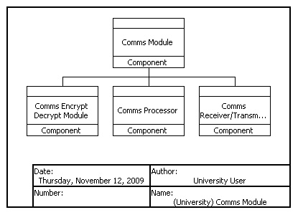  Figure 12: Communications Module Generic Physical Architecture | 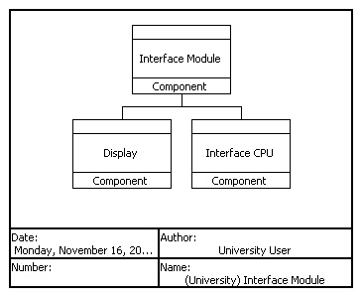  Figure 13: Interface Module Generic Physical Architecture
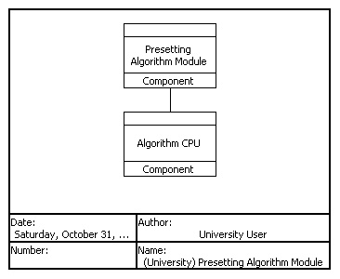  Figure 14: Presetting Algorithm Generic Physical Architecture | 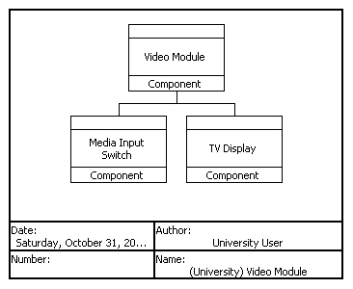  Figure 15: Video Module Generic Physical Architecture

- PHYSICAL INSTANTIATED ARCHITECTURE
A description of the UCATS instantiated Physical Architecture is described in Appendix P. Team DJ³K down selected the instantiated architecture by conducting a series of Analysis of Alternatives (AoAs). When trade-offs were necessary, Team DJ³K used the Stakeholders Value Mapping (SVM) to identify applicable trade-off criteria. Team DJ³K conducted trade-offs using a multi-attribute utility evaluation when there was no clear choice from the options evaluated in the AoA. Table 5 summarizes the instantiated architecture evaluation. Eliminating some of the combinations due to infeasibility conflicts, the total number of possible design combinations was 861 combinations. Obviously, this number will grow considerably during detailed design.

Component | # of Alternates Considered | AoA Conducted | Trade-Off Analysis Conducted
Hardware:
Command and Control (C2) Station | 4 | Yes | Yes
Communications Module
Comms Encrypt/Decrypt Module | 3 | Yes | Yes
Comms Processor | 2 | Yes | Yes
Comms Receiver / Transmitter | 3 | Yes | Yes
Interface Module
Display | 1 | Yes | No
Interface CPU | 1 | Yes | No
Pre-Set Algorithm Module
Algorithm CPU | 1 | No | No
Video Module
Media Input Switch | 1 | No | No
TV Display | 3 | Yes | Yes
Software:
UCATS Software Architecture
User Notifications | 2 | Yes | Yes
UCATS Algorithm | 2 | Yes | Yes
Table 5: Instantiated Physical Architecture Summary

Team DJ³K did not use all the SVM criteria when evaluating the different instantiation combination. Instead, the SVM was tailored to reflect what was applicable for that component. For example, since the Communications Module does not interface with the operator, usability was not an applicable criterion. Likewise, all the processor options had equivalent ability to upgrade for future growth. Extensibility was not considered a valid trade-off criterion since there was no differentiation between the options. Table 6 summarizes the SVM criteria and how they mapped into the different trade-off evaluations.

Component | Applicable SVM Criteria
Component | Accuracy | Affordability | Safety | Security | Reliability | Maintainability | Transparency of Ops | Usability | Availability | Interoperability | Portability | Reproducibility | Performance | Flexibility | Extensibility | Agility
Hardware:
Command and Control (C2) Station |  | Y | Y |  | Y |  |  | Y | Y |  | Y |  | Y
Communications Module
Comms Encrypt/Decrypt Module |  | Y |  |  | Y |  |  |  |  |  |  |  |  | Y | Y | Y
Comms Processor |  | Y |  |  | Y |  |  |  |  |  |  |  | Y
Comms Receiver / Transmitter |  | Y |  |  | Y | Y |  |  | Y |  | Y |  | Y | Y | Y | Y
Video Module
TV Display |  | Y |  |  |  | Y |  | Y |  |  | Y |  | Y
Software:
UCATS Software Architecture
User Notifications |  | Y |  |  |  | Y |  | Y |  |  | Y |  | Y
UCATS Algorithm | Y |  |  |  |  | Y |  |  |  |  |  |  | Y | Y
Table 6: SVM Criteria Trade-Study Summary

Most of the down-select decisions were fairly straightforward with few trade criteria. The C2 Station, displays, processors, and media switches are Commercial-Off-the-Shelf (COTS) items. The difference between one instantiation and another was not significant, or the selected instantiation was so superior to the other options that the trade-study ended up being superfluous. The algorithm and most of the software instantiation was primarily performance driven. The Human Computer Interface (HCI) instantiation was usability driven. Therefore, down-selection of these components is more a function of the quality of the detailed design, which was not done during the system design phase, and less about the system design architecture. The communication module; however, provide the most opportunity for trades and non-COTS instantiations. The communication module also has the greatest need for technology insertion capability, since the proposed instantiated communications module architecture did not provide a design that satisfied all the UCATS performance requirements for all possible scenarios. All the other instantiated architectures of the UCATS components completely met the UCATS SRS. Also, the communication technology had the greatest potential for technological growth. Improvements in Satellite Communications (SATCOM) packet loss and bandwidth, encryption technology, and Global Positioning System (GPS) technology are currently being actively developed. Therefore, for the communication module, SVM criteria for flexibility, extensibility, and agility helped drive key design selections.

COMMUNICATIONS MODULE
    - COMMUNICATION ENCRYPT / DECRYPT MODULE
Options for the communication encrypt / decrypt module included a software only solution, which would reside on the communications processor. This software would perform all encryption / decryption functionality as messages were routed to and from the communication processor. Another option was to buy radios with encryption capability already built into the radios. This is common on military radios. The last option evaluated was to have a stand-alone COTS encryption module. After conducting the AoA, Team DJ³K selected the COTS stand-alone Encryption Module. The primary driver for a COTS stand-alone Encryption Module was upgradeability. It is anticipated that encryption technology will continue to advance and the upgradeability of a combined radio and encryption function would inhibit the ability to upgrade, and the interfaces modifications needed to upgrade a software-only option would also inhibit upgradeability. All the other criteria were fairly equivalent.

COMMUNICATIONS PROCESSOR
Options for the communication processor were a stand-alone communications processor or integrating UCATS communication processor functionality with the UCATS main processor. After conducting the AoA, Team DJ³K selected integrating the UCATS communication processor functionality with the UCATS main processor. The primary reason for combine the communications functions with the main UCATS processor was for reliability. It was decided it would be less reliable to have multiple processors performing discrete functions than it would be to have a single processor performing all UCATS functions, with the necessary redundant processors running in parallel to assure an acceptable reliability. This way, the loss of a single processor did not result in the total loss of that functionality. Additionally, after conducting this AoA, Team DJ³K decided it was unnecessary to conduct similar trade-offs for the other UCATS components; so, the default instantiation was that all UCATS functionality would be run on a single processor (or group of processors running in parallel).
    - COMMUNICATIONS RECEIVER / TRANSMITTER MODULE
An assessment of UAV communications shows that UAVs use both SATCOM and Line-of-Sight (LOS) radio communications; therefore, the UCATS communication design needs to maintain both SATCOM and radio communications. In order to maintain a modular design, which would allow for upgrades if new technology becomes available, these two forms of UAV communication will remain as separate modules. The primary assessment option for the Receiver / Transmitter involves selecting the method used to maintain LOS radio communication with the UAVs, which are known as the LOS antenna options. This is particularly difficult for the UCATS mission because the surveillance UAVs fly in urban areas and can easily be shielded by tall buildings. One options for the LOS antenna was a COTS 100 foot ground-based antenna tower that could be assembled quickly on site. Another option was to use a separate UAV as a communication relay to the surveillance UAVs. The final option was to use a balloon (or Aerostat) as a communication relay to the surveillance UAV. Team DJ³K selected the UAV communication relay option primarily because it provided more reliable LOS communications. Improvements in SATCOM technology will hopefully negate the need for LOS communications. The down-select process used for the communications module is shown in Appendix Q.

INTERFACE MODULE
The interface module hardware consisted of the display and the processor. As discussed in the communications section, it had already been decided to combine the interface processor functionality with the main UCATS processor. The displays were COTS items, and the display options were the number of displays. Team DJ³K determined there should be two Liquid Crystal Displays (LCDs). The decision to use two processors was made in order to meet the UCATS availability requirements. One of the displays was a passive back-up.

The other part of the UCATS interface module was the software HCI design, which determines how UCATS will interact with the user. The specific HCI design has been notionally designed using preliminary usability assessments and documented in the HCI specification, shown in Appendix R, but the final HCI design will require detail design and usability assessments with various operators.

PRESETTING ALGORITHM MODULE
As discussed in the communications module section, the main UCATS processor (or processors) will perform all software functions for the UCATS to include the communications software functions, interface software functions, presetting algorithm and business logic functions, and video software functions. Specifics concerning the algorithm are discussed separately in Section 8. All software Computer Software Configuration Items (CSCIs) are described in Appendix P.

VIDEO MODULE
For simplicity, Team DJ³K decided to use HDMI switch to direct video feeds to the video displays. Like the interface module, display options were evaluated to determine quantity based on usability and not identifying specific types of displays. Primarily for usability issues, Team DJ³K decided to use a single display to provide the video feed to the operator. The interface display passive back-up would provide the same function for the video display. Therefore, UCATS will use three displays: one for user interface, one for video, and one back-up.

C2 DESIGN
The final piece of the instantiated design is the UCATS Command and Control (C2) station. For completeness, Team DJ³K realized that the UCATS components needed to be housed in a mobile C2 station. Options for the C2 station included a C2 trailer; and an integrated C2 station truck; an aircraft C2 station, which negated the need for LOS antennas. Team DJ³K selected the C2 station trailer because it provided high mobility at an affordable cost. The down-select process used for the C2 Design is shown in Appendix T.

SUMMARY
Figure 16 summarizes the UCATS instantiated design. The UCATS system design includes a ground control station trailer that provides high operator safety, distant remote UAVs command and control, simplicity, and environmental protection of the UCATS internal components. The specific components included within the ground control trailer include both SATCOM and LOS radios, an encryption module to encrypt outgoing and decrypt incoming transmissions, and an operator station that contains a PC based computer with processor(s) that runs UCATS software, two displays for UCATS-to-operator interface, and one display for surveillance video. In addition to the ground control trailer, the UCATS will require a UAV to provide a communications relay to the surveillance UAVs. This UAV acts as an extended antenna in the sky to provide LOS communications in an urban environment where shielding by buildings of the LOS signal is highly likely.
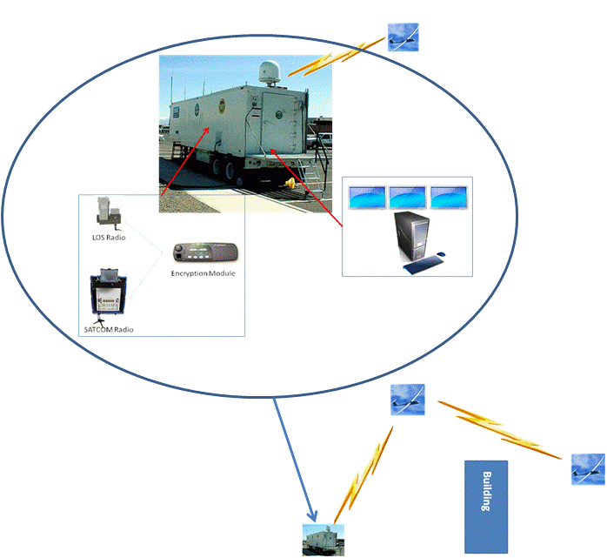
Figure 16: Integrated UCATS Instantiated Architecture
- ALGORITHM DEVELOPMENT
The problem presented to team DJ³K is to assign the UAVs to track TOIs. The TOIs have an associated priority and the highest priority is the most important to track. The operator of UCATS will also be allowed to modify the priority during an engagement. The sponsor indicated that the algorithm should handle cases up to five UAVs and five TOIs with any combination of each.

Priority Algorithm

Team DJ³K developed a priority algorithm to automate the process in which an operator assigns UAVs to track TOIs for UCATS. The algorithm accounts for the user defined property referred to as TOI priority which indicates the TOIs of most importance to the operator. This algorithm is incorporated into a larger simulation tool which depicts a notional user interface to include maps and video display.

The priority algorithm was developed for two alternative solutions, local optimization and global optimization. The Local Optimization algorithm provides the optimal solution for the local problem. The local problem is to determine which UAV is best suited to track a given target in order to minimize the time traveled by the UAV. Therefore the solution to each local problem will yield the UAV with the minimal time required to travel to intercept the target. The main drawback of the local optimization is it analyzes one target at a time without regard for the other targets. This is an implementation of a greedy algorithm.

The Global Optimization algorithm provides the optimal solution for the global problem. In this case the global problem is to determine which UAV is best suited to track a given target in order to minimize the time traveled by the UAV, while considering other targets with the same priority. Therefore the solution to the global problem will yield the set of UAVs to track a given number of targets with the same priority in order to minimize the total time traveled by all UAVs.

Team DJ³K evaluated the proposed UCATS algorithm options by conducting a multi-attribute trade study using a utility model to evaluate the proposed concepts. An analysis of alternatives was performed on two possible solutions for a priority algorithm and DJ³K determined that the best option was the local optimization algorithm. The two options were scored on four criteria, optimization, performance, flexibility, and maintainability. These were weighted based on the team and sponsor objectives. These values were used to determine the final score for each option. The complete analysis can be found in Appendix S which includes the prototyped algorithm code and test results.

Team DJ³K believes the local algorithm will satisfy the sponsor’s needs best because the performance of the local algorithm is faster than the global case. Also the differences in optimizing the problems were not as far off as one may think. The local algorithm proved to be equal to the global algorithm about 80 percent of the time for the samples cases conducted. One aspect not analyzed was the time saved in tracking by the global algorithm versus the local algorithm for the cases in which the two differed. This aspect would be better analyzed during detailed design and with operational data, once available. However, if the customer will always input TOI priorities different for each TOI, then the local algorithm is all that is required because in this case the solutions will always be the same.

UCATS Simulation
While the DJ³K team provided the algorithm aspect of the UCATS system, Ashwin Samant, developed the simulation representing the graphical viewpoint of UCATS. With all of the previously discussed aspects of UCATS, the following aspects of the simulation do not reflect the entire UCATS system and features as they would be in the final version. The simulation’s main intent is to depict the feasibility of UAVs being able to track TOIs based on priority.

The simulation allows the user to enter the number of UAVs and TOIs, and then enter the start locations of both the TOIs and UAVs as well as the stop point of the TOIs. However, the actual UCATS system will retrieve location data from the UAVs that are available for use, so the user will not need to be concerned with this aspect. Also the TOI data will likely be input to UCATS as a tasking order so the user may not need to be concerned with this aspect or even the TOI priority as that may also be included in the tasking order.

Once executed, the simulation determines the intercept path and time for each UAV and TOI combination, and then returns the pairings of UAVs and TOIs. Next, the simulation graphically shows the tracking of TOIs by the respective UAVs assigned to them and allows the user to select multiple viewpoints in which to view the UAV or TOI during the engagement. The UCATS system will also allow the user to modify priorities and TOIs during the engagement which is not a part of the simulation.

- BUSINESS CASE
The UCATS system includes the hardware and software described in Section 7, needed to conduct the desired C2 operations. All the hardware is COTS. From a business perspective, the software development represents Team DJ³K’s core value and competency due to its uniqueness. Unlike the hardware, which can be procured from any number of commercial suppliers, the software represents the unique intellectual property of the UCATS design. More specifically, the algorithm design is the most unique part of UCATS due to its ability to provide UAV to TOI assignments and compute intercept courses product includes a newly designed and implemented algorithm. This algorithm is unique in the sense that it prioritizes targets and optimally assigns UAVs to targets of interest. The end result is a reduction in the manpower needed to control up to 5 UAVs.

Compared to the manufacturing of UAV flight hardware, the market for autonomy technology is fairly immature and undeveloped. Because of this, autonomy has been and may continue to be the bottleneck for future UAV developments, and the overall value and rate of expansion of the future UAV market could be largely driven by advances to be made in the field of autonomy. By emphasizing the need for reducing the number of operators required, coupled by the already evident benefit of flying an unmanned aircraft (i.e. reduction in collateral damage, etc.) the UCATS product will fill a critical void in today’s market.

With a market value of $2.2 billion in 2007 (Figure 17 below), UAVs represent the largest and most mature segment in the unmanned systems marketplace.
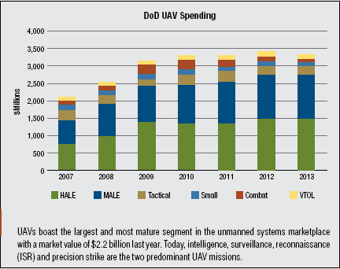
Figure 17: DoD UAV Spending

As the result of successful performances in Iraq and Afghanistan, UAVs that fly high and medium altitude long endurance missions have been the beneficiaries of the latest technologies and consequently received more than $1.8 billion in DoD funding in 2007. Eighty percent of this spending went to the U.S. Air Force’s medium altitude long endurance (MALE) and high altitude long endurance (HALE) platforms. However, the USAF is not the only military service with these capabilities; the Navy’s Broad Area Maritime Surveillance (BAMS) program will have a substantial impact on defense spending in addition to the Army’s Extended Range, Multi Purpose (ERMP) aircraft. These two programs are expanding long endurance UAV capabilities across the military services.

The Business Case document included in Appendix U contains a description of the economic factors that were used to develop cost estimates. It contains the results of the business case: price, cash flow analysis, net present value, internal rate of return, and breakeven point. The business case also takes into consideration the inputs from the SVM Document. Team DJ³K’s business concept for UCATS is to develop it using sponsor funding and sell it to DoD customers. Once UCATS is developed, Team DJ³K intends to seek out additional customers in military, homeland defense, and law enforcement that may be interested in procuring UCATS.

A sensitivity analysis was performed on the baseline (as seen in the Figure 18 below), which included a better option (more favorable market conditions) and a worse option (less favorable market conditions). This sensitivity analysis was performed to determine how market fluctuations can affect the profitability and risk of the project. Team DJ³K also performed a decision analysis using an influence diagram and decision tree. These were used to determine whether it was more favorable to develop the system in-house or hire a sub-contractor. The analysis determined that the best option was to develop the system in-house. For the more details on the business case see Appendix U.

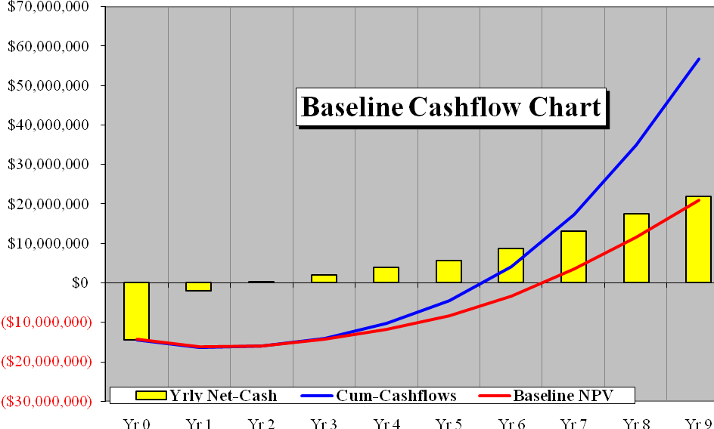
Figure 18: Baseline Cash flow Chart
- FUTURE WORK
The next step in the development of UCATS is to take the system level design and proceed to preliminary and final detailed design of all the configuration items described in the instantiated physical architecture. This would include making the final hardware selections and maturing the algorithm and UCATS software so that it is ready for delivery to the customer.

Key work that still needs to be accomplished is:
- Hardware Selections: The follow-on effort will need to select the specific C2 trailer, SATCOM and LOS radios, encryption module, computer, and display the UCATS will use in the final design. One key hardware decision involves selecting the UAV for the LOS communications relay. The follow-on UCATS design team will need to determine if the communication UAV is part of UCATS, or if UCATS just selects one of the available surveillance UAVs to act as a communication relay. Additionally, the follow-on designers may determine that the communication UAV is not the optimal solution and try a different alternative. Also, the customer may decide after seeing the UAV cost, they do not need a continuous stream of surveillance video, which would change the AoA results and significantly reduce UCATS costs.
- Software Development: The majority of the follow-on work involved the detailed design of the UCATS software. A key aspect of the software development involves the development of the UCATS HCI. The HCI will require additional usability assessments to obtain a final design. The initial usability assessment used during the development of the System Level HCI design was not sufficient for the final design instantiation.
- Algorithm Development: The system level UCATS algorithm development was a prototype used primarily for feasibility assessments. It does not contain all the functionality desired by the customer. Refinement of the algorithm to address the full UCATS functionality will be a key aspect of the follow-on design effort. The algorithm will also need to include more real world limitations and constraints such as fuel levels and consumption rates for the UAV, wind speed and direction, as well as changing weather conditions, and smaller-sized TOIs. The UCATS is initially intended for urban environments, but can easily be deployed in other environments. Additionally, further refining the algorithm can allow the system to track people.
- Systems Engineering Artifact Updates: Based on the design decisions made during detailed design, the follow on design team will need to update the appropriate systems engineering products and artifacts to reflect the maturation of the system level design. The analyses performed on the UCATS can be expanded further. For example, the system architectures can be modified to include more detail, such as one additional level (e.g. level 3). This improved resolution would add more detail to the analyses of alternatives, risk analysis, requirements, and business case. In particular, this would benefit the business case through better cost estimates, as well as a more realistic decision analysis.
- Business Case Update: The follow-on team will need to update the business case to reflect any new design decisions. Overall UCATS cost could change substantially.
- Technology Plan: The follow-on design team will need to develop a technology roadmap for the UCATS-to-UAV communications. Currently SATCOM radios do not provide the reliability and bandwidth needed for UAV communications in urban environments, especially when transmitting continuous video streams. The use of a UAV communication relay for LOS operations is an interim solution at best. Ideally, some of the current SATCOM technology initiatives will come to fruition within the next five years, and UCATS will be able to eliminate the need for LOS communications entirely, and significantly reduce complexity and cost, as well as increase reliability.
- Stakeholder Involvement: The primary focus of this project was to satisfy the needs of our stakeholder K.C. Chang. However, needs of the other stakeholders (DHS, DEA, CBP, FBI, and CIA) should be further analyzed.
- CONCLUSIONS AND RECOMMENDATIONS
Team DJ³K used a discipline systems engineering approach to develop the system design of UCATS. This discipline systems engineering approach involved using an embedded spiral development within the “Vee” Model.

During the development of the UCATS systems design Team DJ³K defined the system level problem by developing the problem statement and mission statement, developing a CONOPs, developing the SVM, and conducting SOS modeling, which resulted in an external systems document and needed UCATS functionality. Next, Team DJ³K generated the UCATS SRS. Finally, Team DJ³K generated the system level functional and physical architectures for UCATS. This system level design resulted in a UCATS system design that is capable of communicating with UAVs, generating TOI intercept plans, and interfacing with the operator. Additionally, Team DJ³K generated a business case from the instantiated system level UCATS design.
Key products generated during the development of the UCATS systems design included:
- Programmatic Documents used to guide the development of the UCATS Systems design which included a project plan, PAP, RMP, SEMP, stakeholder mapping and business case analysis.
- SOS Modeling Documents used to determine desired UCATS functionality which included SOS use cases and activity diagrams and an external systems diagram for UCATS.
- UCATS System Design Documents used to facilitate the development or described the system design which included AoAs for all major design decisions, an SRS, functional and physical system architecture, and an algorithm prototype.

Based on these products, Team DJ³K determined the instantiated UCATS Physical design was a ground control trailer that had both SATCOM and LOS radios, an encryption module to encrypt outgoing and decrypt incoming transmissions, and an operator station that contains a PC based computer with processor(s) that runs UCATS software and algorithm, two displays for UCATS-to-operator interface, and one display for surveillance video. In addition to the ground control trailer, it is recommended that a UAV be used as a communication relay to the surveillance UAVs to greatly improve the performance and availability of communications.

The scope of this effort did not include the recommendation of a specific UAV system. This was done for three reasons: (1) User preference - the UCATS will not be designed to operate with a specific UAV, but rather will allow the customer to choose the UAV system it will control. (2) Modularity and upgradeability – as newer and better technologies become available; the UCATS will be capable of integrating with them due to the open system design. (3) Business case – choosing a specific UAV system would create a financial dependency on an additional party, and being able to integrate with multiple systems would give the product an advantage from a business perspective.

It is recommended the GMU concur with the UCATS System Design and Business Case.

APPENDICES

Appendix A: ACRONYMS
AoA Analysis of Alternatives
CBP Customs & Birder Protection
CIA Central Intelligence Agency
CONOPS Concept of Operations
C2 Command and Control
CPU Central Processing Unit
CSCIs Computer Software Configuration Items
COMMS Communications
COTS Commercial-Off-the-Shelf
DEA Drug Enforcement Administration
DHS Department of Homeland Security
DoD Department of Defense
DoDAF Department of Defense Architecture Framework
FBI Federal Bureau of Investigation
GMU George Mason University
GPS Global Positioning System
GUI Graphical User Interface
GWT Global War On Terror
HCI Human Computer Interface
HDMI High-Definition Multimedia Interface
LCD Liquid Crystal Displays
LOS Line-of-Sight
PAP Product Assurance Plan
PM Program Manager
RMP Risk Management Plan
SATCOM Satellite Communications
SEMP Systems Engineering Management Plan
SEM System Engineering Management
SEOR Systems Engineering & Operations Research
SOS System of Systems
SOW Statement of Work
SRS System Requirements Specification
SVM Stakeholder Value Mapping
TOI Target of Interest
UAV Unmanned Air Vehicle
UCATS Unmanned Control & Tracking System
WBS Work Breakdown Structure
Appendix B: ASSUMPTIONS

DJ³K Project Team worked under the following assumptions:
- The algorithm for tracking provided by Ashwin is in good working order and takes into account obstacle avoidance.
- UAVs will not communicate with each other only with a communication node. The communication node contains a global picture of the UAVs.
- Each UAV comes with camera.
- Values provided for goals are an estimated guess.
- An operator can always interrupt the autonomous tracking.
- No-fly zones are preloaded with the maps.
- Targets follow traffic direction laws.
- UAVs fly above building height.
- A tasking authority provides the initial target location.
- Fuel tank level is not taken into consideration in the assignment of UAVs since it is assumed that all UAVs.

Appendix C: STATEMENT OF WORK

Statement of Work (SOW)

Appendix D: STAKEHOLDER VALUE MAPPING

Stakeholder Value Mapping

Appendix E: CONCEPT OF OPERATIONS

CONOPs

Appendix F: PROJECT MANAGEMENT PLAN

Project Management Plan (PMP

Appendix G: SYSTEM OF SYSTEMS CORE FILES

System-of-System Functionality
External Systems CORE File

Appendix H: SYSTEMS ENGINEERING MANAGEMENT PLAN

Systems Engineering Management Plan (SEMP)

Appendix I: PRODUCT ASSURANCE PLAN

Product Assurance Plan (PAP)

Appendix J: RISK MANAGEMENT PLAN

Risk Management Plan (RMP)

Appendix K: SYSTEM REQUIREMENT SPECIFICATION

System Requirements Specification (SRS)

Appendix L: USE CASES

Use Cases

Appendix M: ACTIVITY DIAGRAMS

Activity Diagrams
Appendix N: P-DIAGRAM

P Diagram

Appendix O: FUNCTIONAL MODEL ANALYSIS

Functional Model Analysis

Appendix P: ARCHITECTURE

System Functional Architecture
System Functional Architecture CORE File

Appendix Q: COMMUNICATION ANALYSIS OF ALTERNATIVES

Comms AoA

Appendix R: HUMAN COMPUTER INTERFACE SPECIFICATION

HCI Spec

Appendix S: ALGORITHM ANALYSIS OF ALTERNATIVES

Priority Algorithm AoA

Appendix T: GROUND CONTROL ANALYSIS OF ALTERNATIVES

C2 AoA

Appendix U: BUSINESS CASE

Business Case
Business Case - Excel File
Business Case - DA File

Appendix V: REFERENCES
Ding, X.C., Powers, M., Egerstedt, M., Young, S., Balch, T. (2009). Executive Decision Support. IEEE Xplore

Chen, H.; Chang, K.C.; Agate, C.S. (2009). Tracking with UAV Using Tangent-Plus-Lyapunov
Vector Field Guidance. 12th International Conference on Information Fusion

http://www.cotsjournalonline.com/articles/view/100867

